ANSWER 1. Creating file – mkdir test_dir

Create an empty file - touch test_dir/example.txt

Rename – mv test_dir/example.txt test_dir/renamed_example.txt

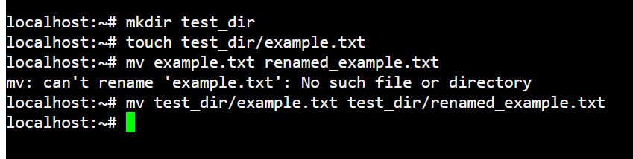

ANSWER 2 - Display contents - cat etc

First 5 lines - head -n 5 etc

last 5 lines - tail -n 5 etc

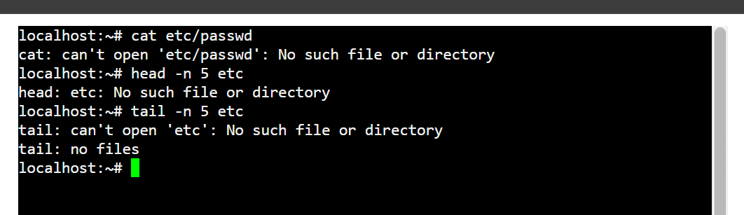

ANSWER 3 – cat etc | grep root

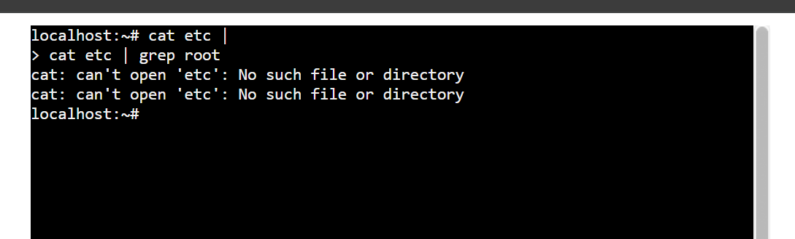

ANSWER 4 - Zipping – zip test_dir.zip test_dirv

Unzipping - unzip test_dir.zip unzipped_dir



ANSWER 5 – Wget https://reqres.in/

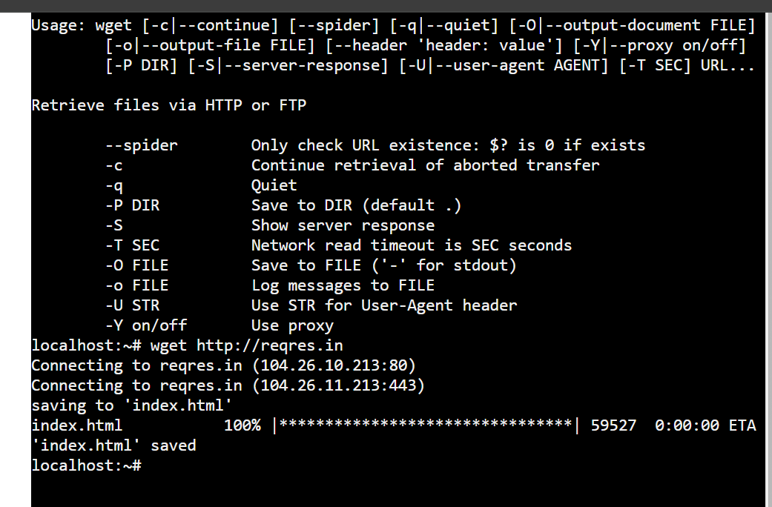

ANSWER 6 - touch secure.txt

chmod 444 secure.txt

Checking permission - ls -l secure.txt

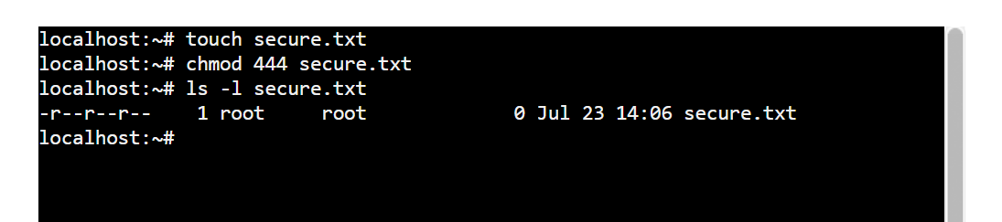

ANSWER 7 - export MY_VAR="Hello, Linux!"

